Network Monitoring
System
Group 08

Initial Report
Group members:
Lau Chun Yin Jacky 130226235
Siu Man Ho 130297142
Iu Hiu Pan Albert 130351532
Tam Siu Kei Eddy 130548064
IT114104

Content

Introduction 2
Expected Stakeholders 3
Overview of the Proposed Solution 4
Limitation 5
Required Resources 6
Expected Deliverables 7
Project Schedule 8
Task and Role of Each Student 9
System development 10
Conclusion 11
References 12

Introduction
Through the development of technology, more and more company are using the internet to operate their business and it bring a lot of advantages to the company. Under the e-business, the development and services of company will not limited by space and time. The company also can provide more diversified services on different platform such as mobile. Most businesses rely more or less on a computer and network infrastructure. So, the computer network's reliability and speed are crucial for these businesses to be successful, it may cause huge economic losses if there are some network congestion. The network structure of company will become complex through the development of company. Wherefore, it is very hard to find out the problem in so many devices when network problems. So, a good network management is important, proper management of a network results in a system that has the capacity and features to meet the needs of it's users without wasting resources on overcapacity and frills. Improper management results in an unreliable system that is prone to failure when most needed, is open to attack, wastes the time of the people trying to use it and fails to deliver value for the investment.

Therefore we would like to develop a Network Monitoring System (NMS) with a GUI using SNMP which is a build-in service of different devices, such as PC, switch, router. In the system, we can get different information of devices in the network. For example, we can get the CPU load, memory load, bandwidth usage etc. This system aims to help network administrator to monitor the network and find out the problem easily.

Expected Stakeholders
Company

For the company, it aims to help the network administrator to get network and devices status more easily. This network monitoring system may not solve the network problem automatically, but it will help the administrator troubleshoot the issue by allowing them to compare the company network’s current state with what it looked like before the change. It help the administrator to solve the problem faster, to maintain the company's work efficiency. Besides, the company can also use for security, they can use it to check the port status or some unknown traffic, help them to identify vulnerability quickly and fix it. If a device is constantly down, or the bandwidth to a specific subnet is constantly running near the limit, it may be time to make a change. Network monitoring applications allow administrator to track this type of data and make appropriate changes with ease, to help them to plan for upgrades or changes.

Home user

For the home user, they may not need to get as much information as a network administrator, but they still can use it to help them to get basic information of their system, such as CPU load, memory load, bandwidth usage etc. help them to make a small management for their home PC.

Overview of the Proposed Solution
Overview of the proposed solution
Our Network Monitoring System aims to provide a GUI platform to the user for monitoring the LAN. It provides the following features:
- Network Traffic Monitoring
- Failure identification
- Provide information of the Device Hardware Status
- Graphic User Interface
- DBMS storage
- Log Generating
Network Traffic Monitoring
This feature is the main function of this program. We will capture the network status from different device by SNMP. It aims to packet capture and analyze the packet (using SNTP4J).

Failure identification
Since we are using SNMP for monitoring, there is a one thing call ‘trap’. When some device has failure, the agent will send a trap to network monitoring system. We using the trap to identify which device have failure.

Provide information of the Device’s Hardware Status
This feature can provide the performance of the hardware. It aims to monitoring; collect the information and analysis for a suitable solution to grantee the performance of the network.

Graphic User Interface
This features provide allows the user to interact with the program by using mouse.
It can provide more data representation. For example, different graphs, button etc.

DBMS for storage the history
When the program finishes the capture, user can select the option to save the current result to DBMS.

Log Generating
When the program finish captures the status of device and saving to DBMS, the user
can output the current result to a text file for record.

Limitation
The limitation of this system is it cannot update the status of device by real time. The reason is we will monitor the LAN by using SNMP protocol. If we using real time to update the status of the device. It will make the burden on the network.

Required Resources
Software: | Eclipse
Software: | VMware Workstation
Operating System: | Windows 7
Operating System: | Windows Server 2008 R2
Application Runtime: | Java (snmp4j)
GUI: | Java
Hardware: | Switch
Hardware: | Router
Hardware: | Client PC
Database management System: | MySQL

For the hardware, we will use Router, Switch and PCs to build up a network and to test whether the program run normally.

For the software we use Eclipse for developing our software and VMware for preliminary tests. We will use API called SNMP4J which provide a library for us to send request to agent for getting devices status and swing for GUI developing. Besides, we will use MySQL for saving the status of devices.

Expected Deliverables
We assure the network monitoring can bring achievements and contributions. It offer a better efficiency of management and monitoring to small and medium enterprise, to provide a better network monitoring.

We expected deliverables are CD or DVD, user manual, GUI of application. The application can install with a CD or DVD. The user manual can provide detail control of the system and the user can study it for a better experience on the system. For the GUI, it offer a simple user interface, to let everyone can handle the system easily.

Project Schedule
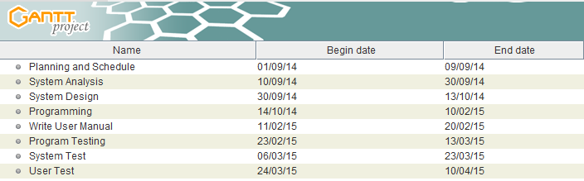
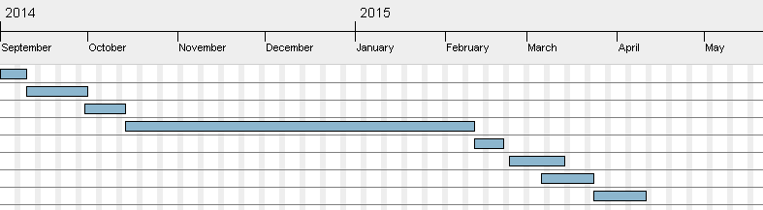

Task and Role of Each Student
Initial Report | Tam Siu Kei | Iu Hiu Pan | Siu Man Ho | Lau Chun Yin
Introduction |  | ✓
Expected Stakeholders |  | ✓
Overview | ✓
Required resources |  | ✓ | ✓
Expected Deliverables |  |  |  | ✓
Project Schedule | ✓
Task and Role of Students |  |  |  | ✓
Conclusion |  | ✓ | ✓
References | ✓ | ✓ | ✓ | ✓

System development

Tam Siu Kei | Program Design  Study Related Language (SNMP4J)  Database operation  System Implementation  System Analysis  Testing & Debug
Iu Hiu Pan | Program Design  Study Related Language (SNMP4J)  System Analysis  System Implementation  Testing & Debug  Database Design
Siu Man Ho | Design interface graphic  GUI Implementation  Study Related Language (Swing)  Database operation  Testing & Debug  Hardware Installation
Lau Chun Yin | Design interface graphic  GUI Implementation  Study Related Language (Swing)  Testing & Debug  Hardware Installation

Conclusion
All companies are different, but the value of their network to their business varies little. In fact, as a business grows, its network grows not only in size and complexity, but also in significance and value. The more you know your network, the more you can assure internal and external users that your network will be able to achieve performance and availability goals. That is the reasons why we want develop a network monitoring system to assist a company to manage their network.

For the stakeholders, there are two main targets which is company and home user, for the company usage, they may need a higher requirement and they need more information for network management. About the home user, they may need less information for computer management.

Regarding to the feature, our system aims to provide a GUI platform for the user to monitor the network. Therefore, there are 6 main features we will provide, they are Network Traffic Monitoring, Failure identification, Provide information of the Device’s Hardware Status, Graphic User Interface, DBMS for storage the history and Log Generating.

This report is our initial idea of the whole project.

References
Websites:

SNMP4J.org, 2003-2014, retrieved from http://www.snmp4j.org/

Wiki, 6/10/2014, retrieved from http://en.wikipedia.org...._Protocol

Jiltendra, 23/2/2011, retrieved from http://www.shivasoft.in/......java-using-snmp4j/

iDeskCentric Inc. ,2002-2014,retrieved from http://www.ireasoning.com/

Sun Microsystems, Inc, 2004, retrieved from http://docs.oracle.com/.../snmp.html

Book:

作者: 林智揚 出版社:中國鐵道出版社
書名: 精通Java swing 程式設計

作者: 許清榮 出版社: 博碩文化
書名: Java 視窗應用程式設計與 SCJP 認證實戰演練

作者: Elliotte Rusty Harold出版日期：2005年11月
書名: Java 網路程式設計 第三版

作者: 桂思強
書名: 網路程式設計Java = Network programming

作者: William Stallings
書名: SNMP, SNMPv2, SNMPv3 and RMON1 and 2

